CSC2521 Assignment 3

Ziheng Liang

Square Simulation Results

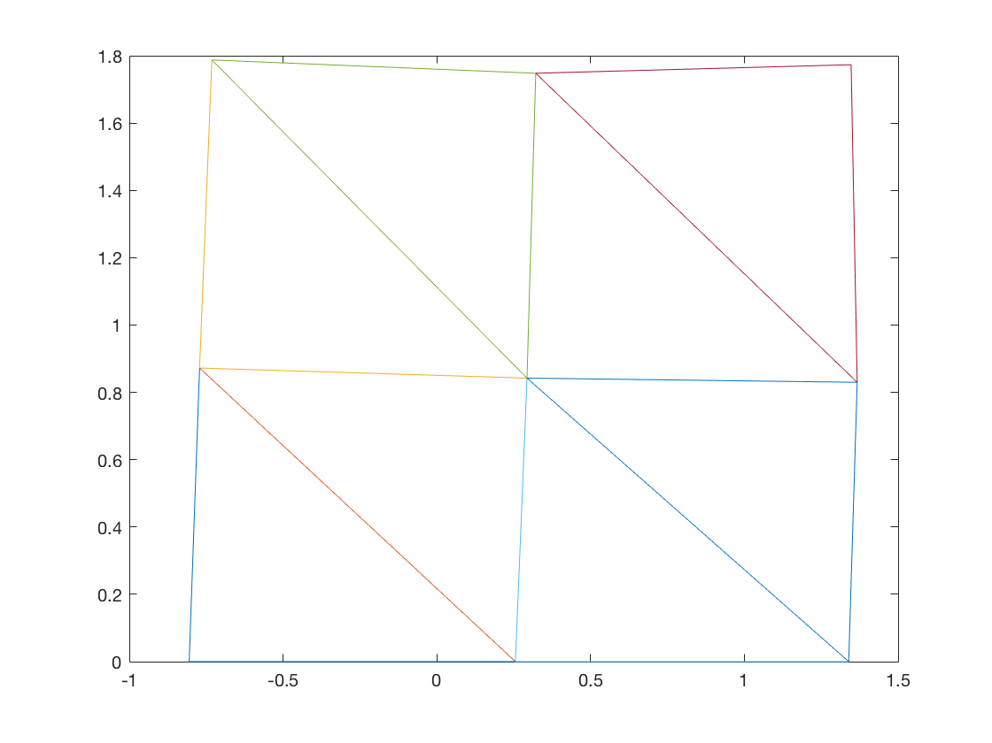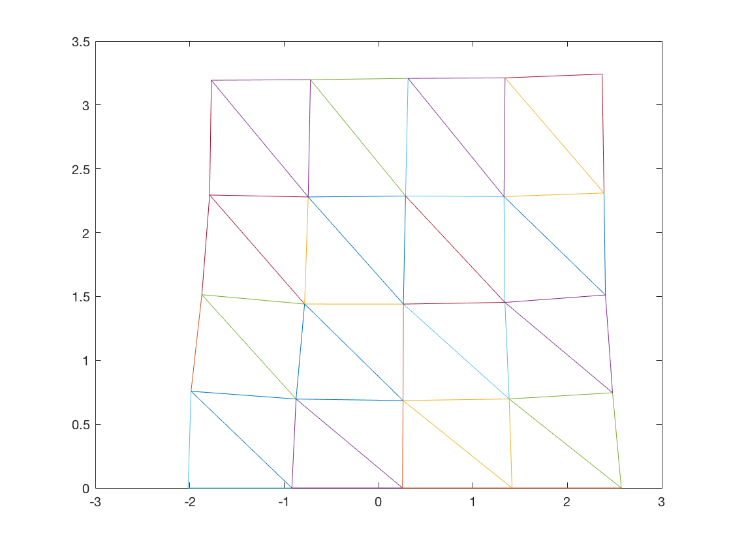

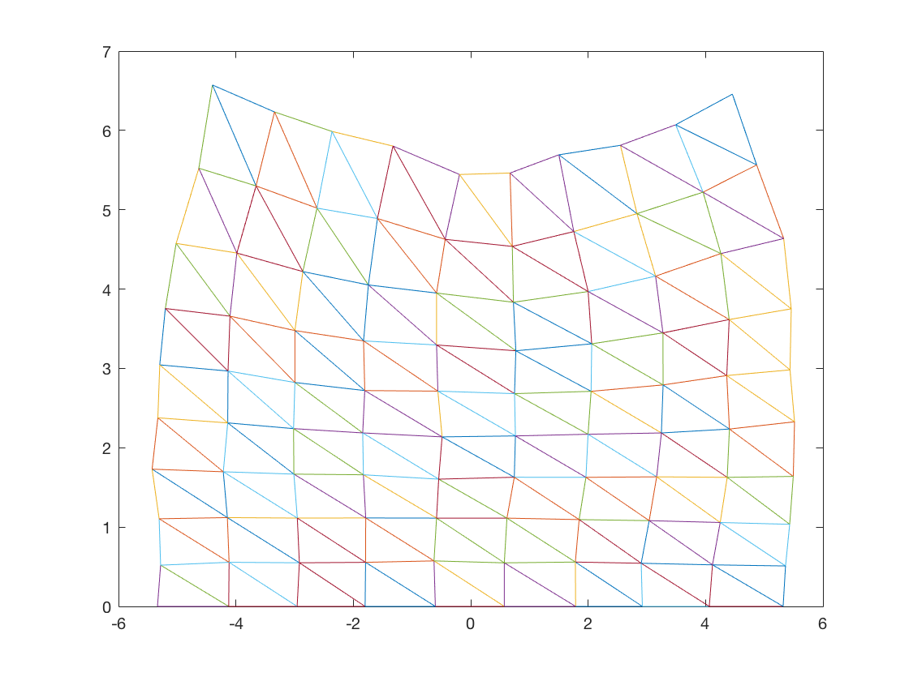

Non-Square Simulation Result

For this assignment, I’ve created two more shapes other than square. There is a simpler circle and a more complex human shape.

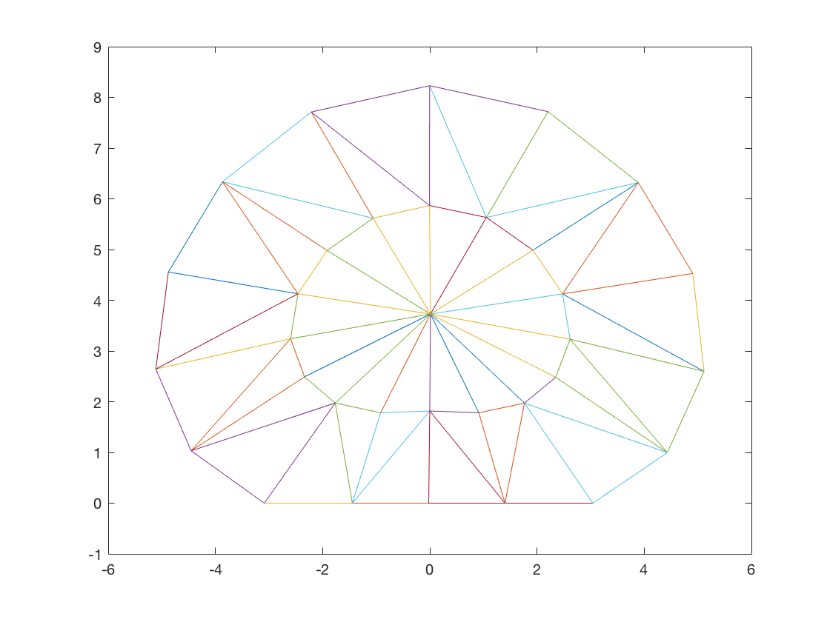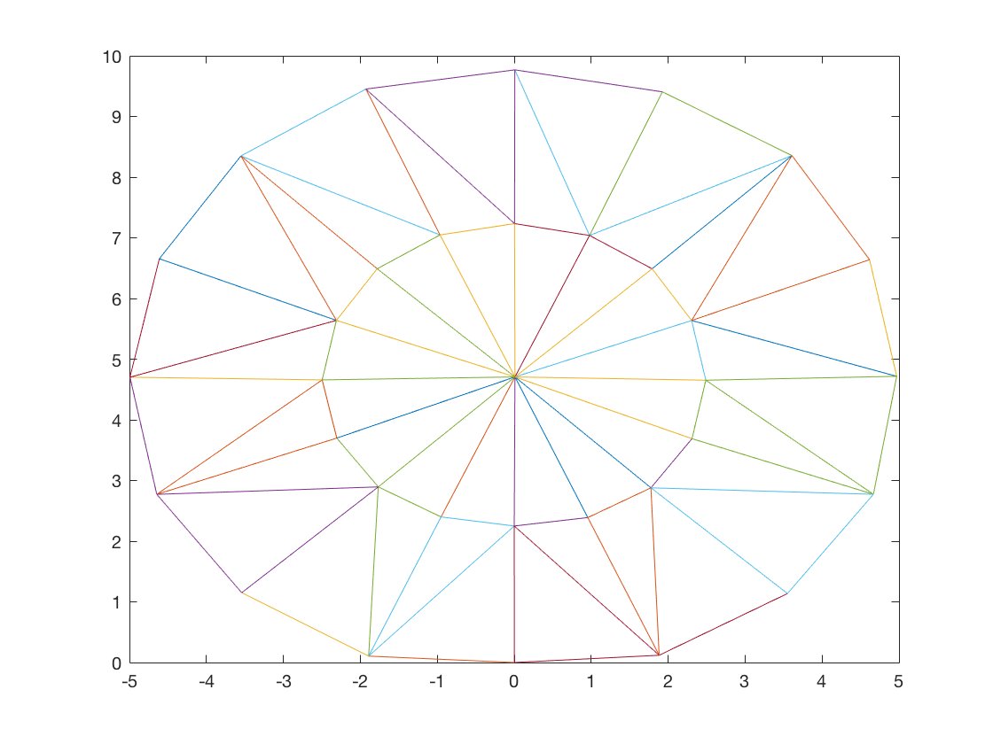

Left side is soft material for a circle, right side is a hard material.

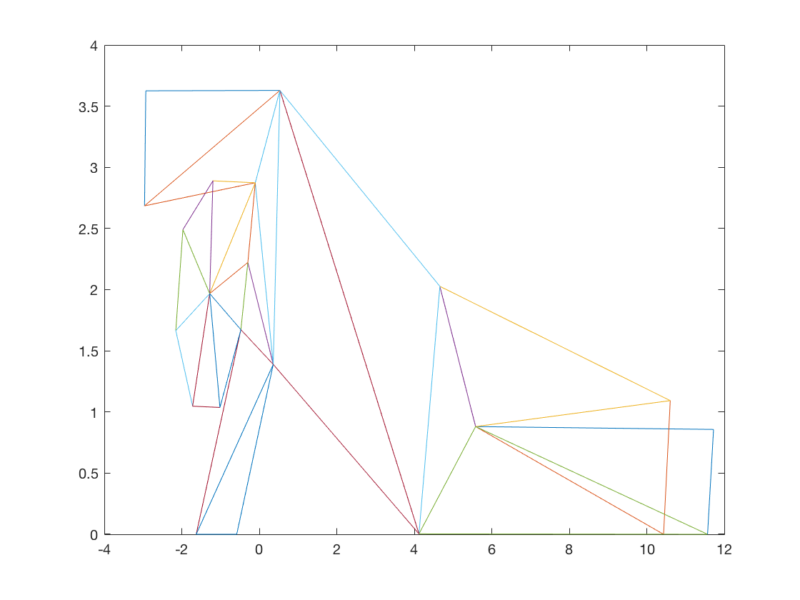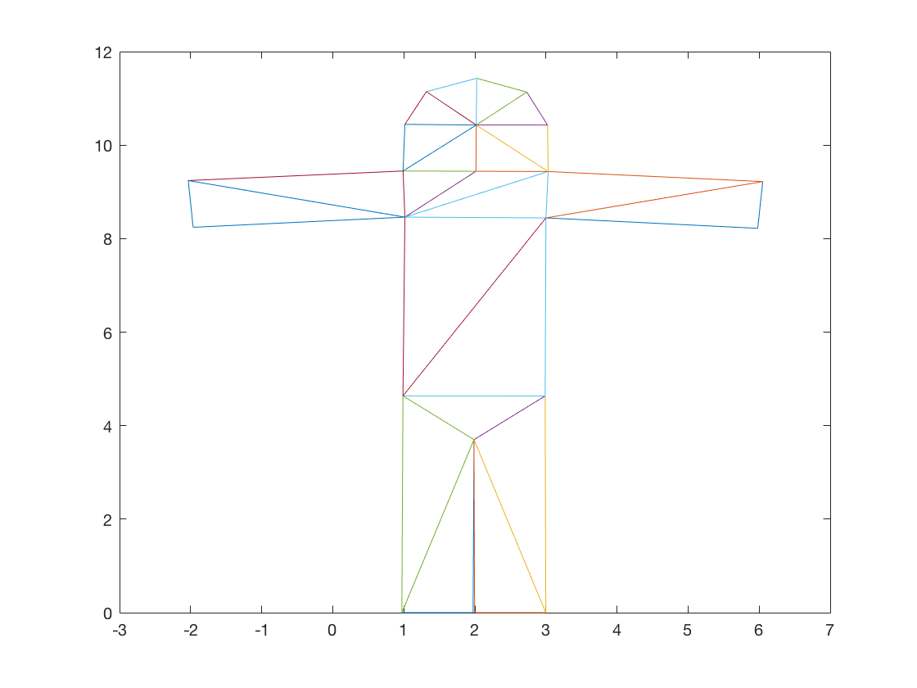

Left side is soft material for a human, right side is a hard material.

Circle always works reasonably well with various material. On the other hand, human shape only works with hard material. A soft human will fall to the side and the simulation just become uglier and uglier.

Code:

I’ve modify the starter code so that all the points’ y value will not be below 0. Y component of velocity of a vertex will be set to zero if the vertex is on the ground and its value is negative, but a positive value will remain the same. This change is to create a virtual ground at y=0. And to create a bounce back effect.